**May 9th Tasks -------------------------------------------------------------------**

**Task 1 : File Navigation and Directory Structure**

Objective: Demonstrate basic file navigation and directory structure understanding.

Action Items: List all files in the home directory using a single command.

Display the absolute path of the current working directory.

Create a new directory called Practice in the home directory and navigate into it.

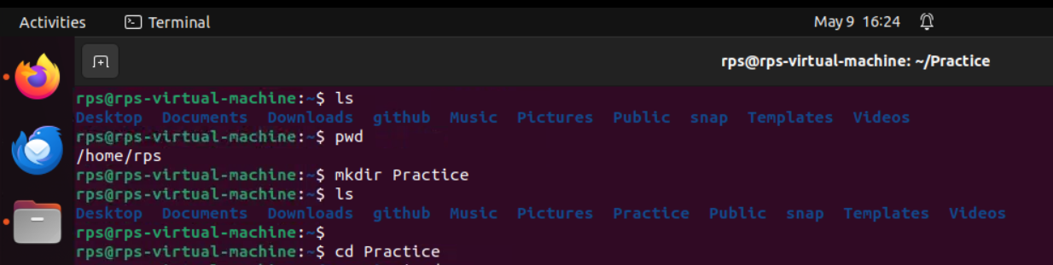

**Task 2 : File Management Commands**

Objective: Use file management commands to organize files and directories.

Action Items:

In the Practice directory, create a new file called sample.txt.

Copy sample.txt to a new file called duplicate.txt.

Delete duplicate.txt using a command-line command.

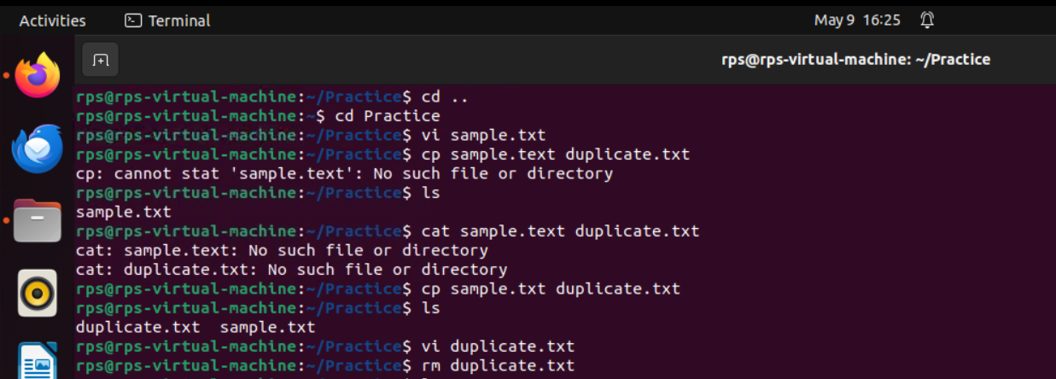

**Task 3 : Using grep to Search within Files**

Objective: Utilize grep to search text within files.

Action Items:

Use grep to find all instances of the word "Linux" in the LinuxHistory.txt file.

Redirect the output to a new file called LinuxInstances.txt.



**Task 4 : Permissions and Ownership**

Objective: Understand and modify file permissions and ownership.

Action Items:

View the current permissions for sample.txt.

Change the permissions to read-only for the owner and no permissions for others.

Change the ownership of LinuxHistory.txt to another user (assuming one exists).

